U-8 Girls Game Schedule
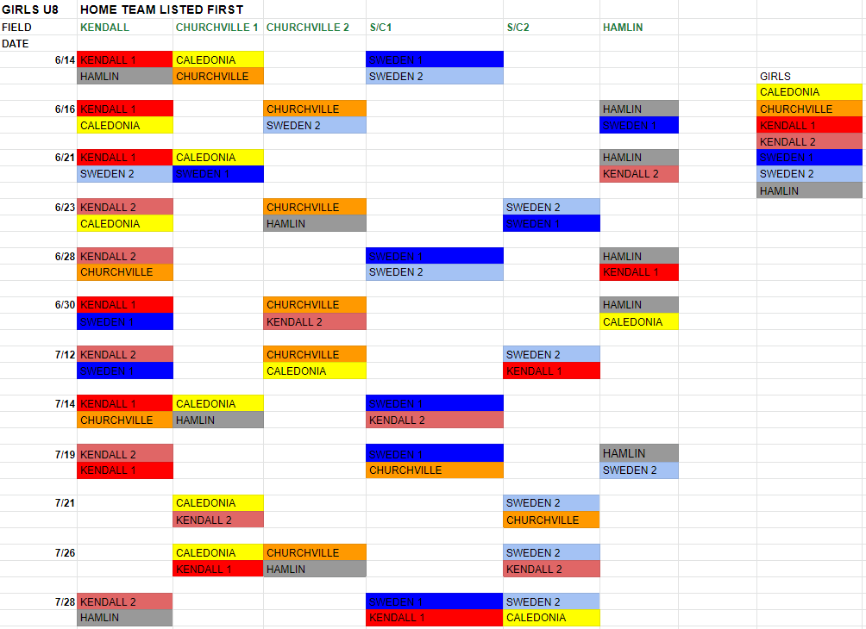

Hamlin Town park- 1658 Lake Rd. Hamlin, NY 14464
S/C -4927 Lake Rd. South Brockport, NY
Kendall Elementary School- 1932 Kendall Rd, Kendall, NY 14476
Churchville- Churchville Park (Cottonwood) - 629 Kendall Rd, Churchville, NY 14428

