U-8 Boys Game Schedule

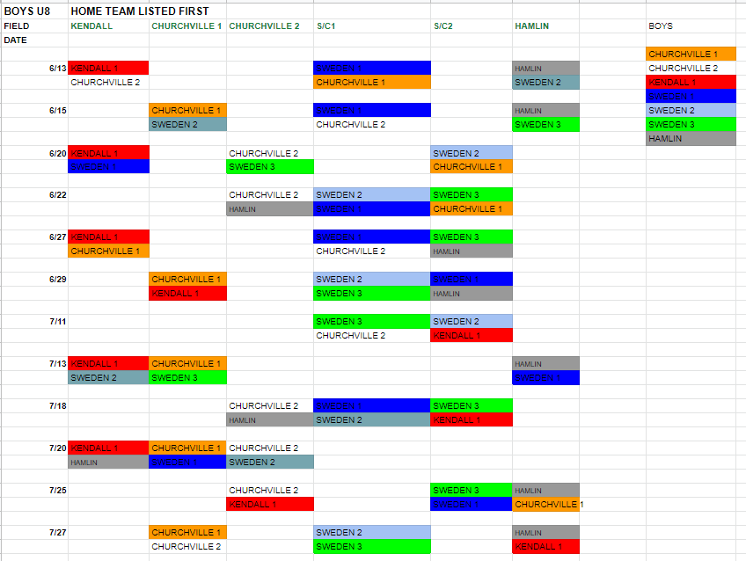

Hamlin Town park- 1658 Lake rd. Hamlin, NY 14464
S/C- 4927 Lake Rd. South Brockport, NY
Kendall Elementary School- 1932 Kendall Rd, Kendall, NY 14476
Churchville- Churchville Park (Cottonwood) - 629 Kendall Rd, Churchville, NY 14428

